University of Wolverhampton
School of Mathematics and Computer Science

6CS005 High Performance Computing Week 7 Workshop
Tasks – More OpenMP Multithreading
- The following program uses semaphores to manage the loan of 3 books to a group of 5 borrowers:
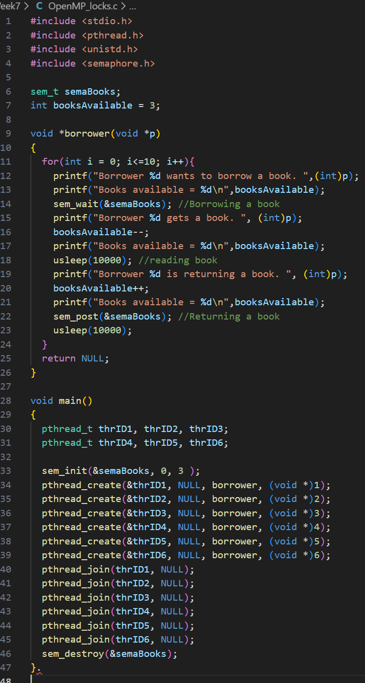

- Convert it to use OpenMP locks.
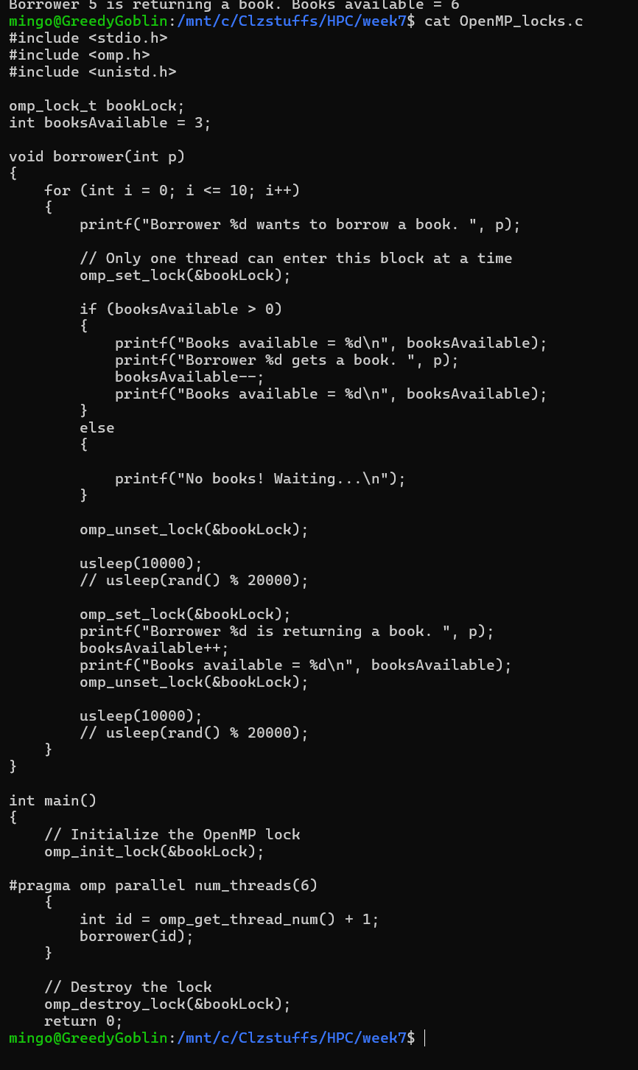
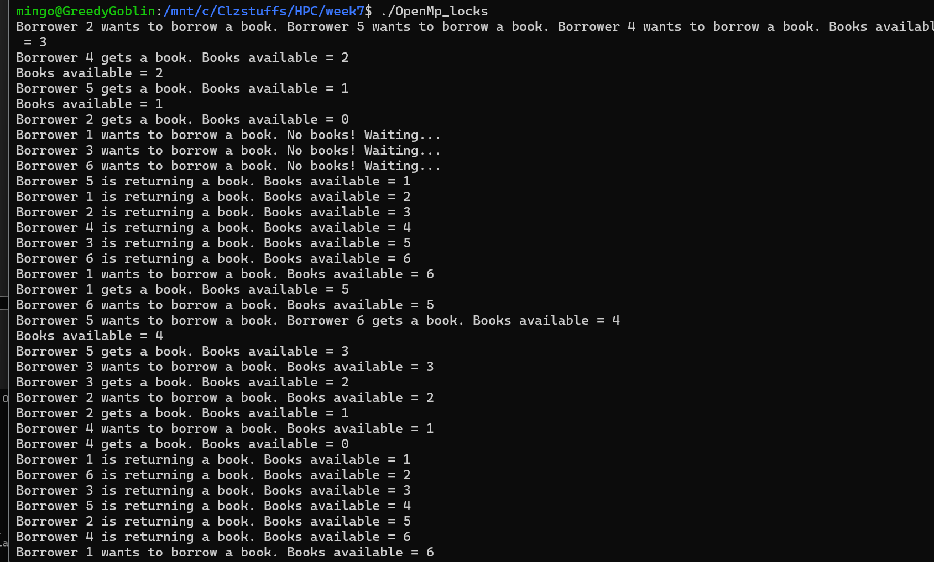

- Modify the program so that it doesn't use locks.
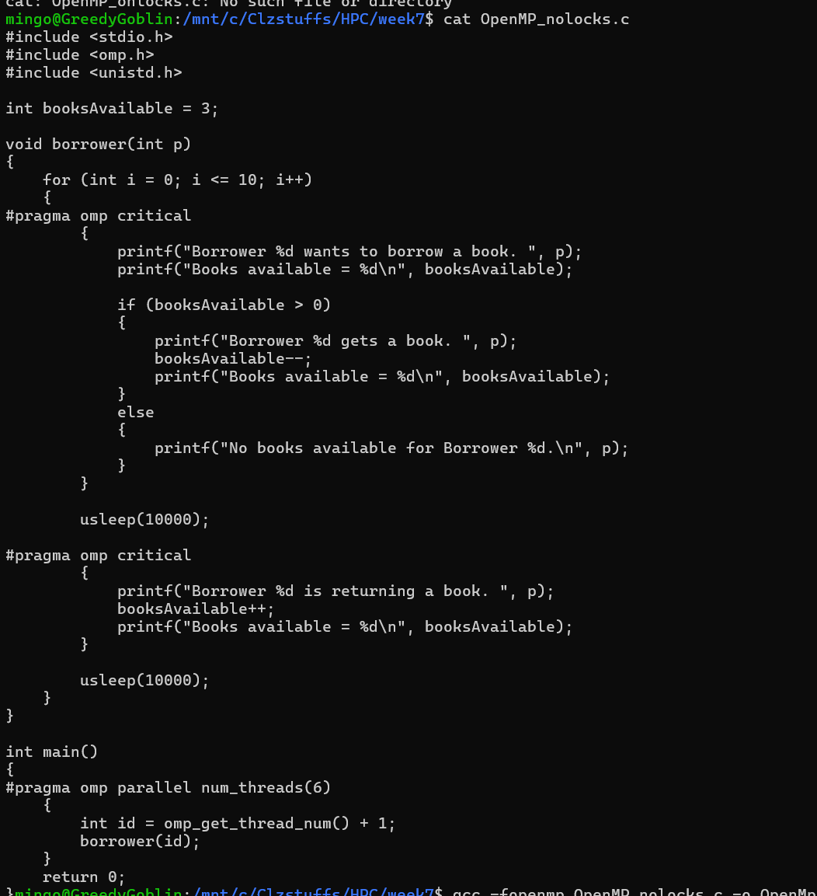
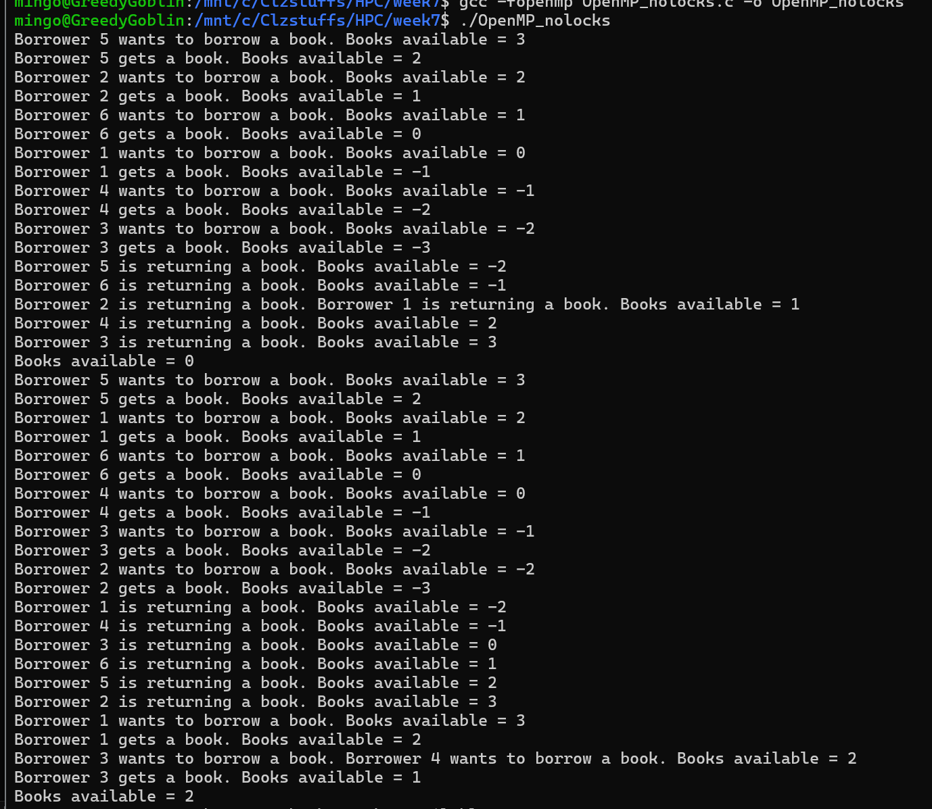

2.The following program encodes 3 lower case letters into a numeric code:

Enter it as "encode.c", build and run it and then enter 3 lower case letters. Note down the code it produces
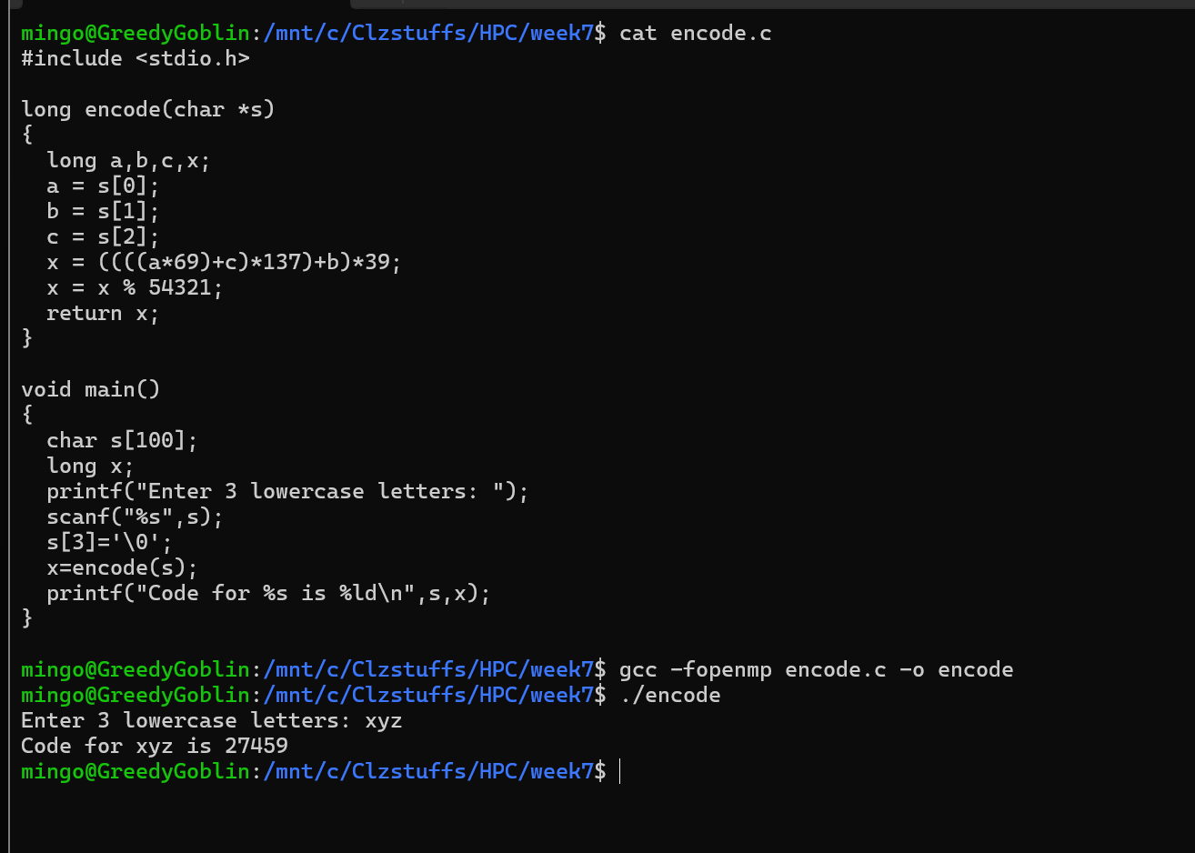
The next program attempts to decode the code back to the original 3 letters.:
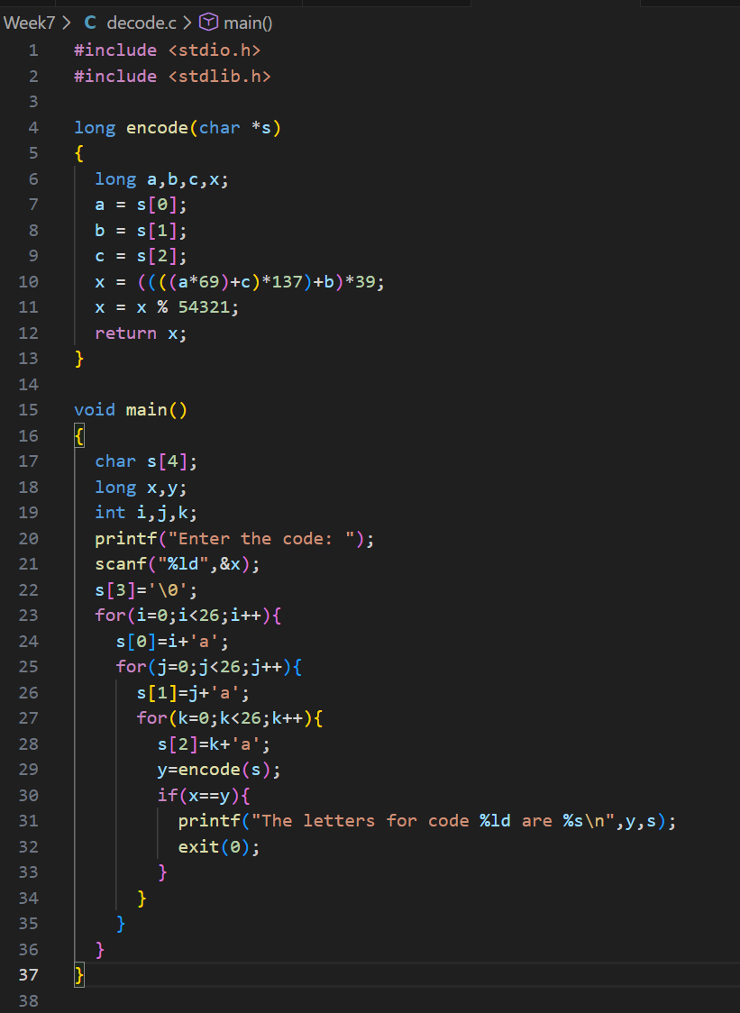
a.Enter it as "decode.c", build and run it and verify that it decodes the letters successfully from the numeric generated by the previous program.
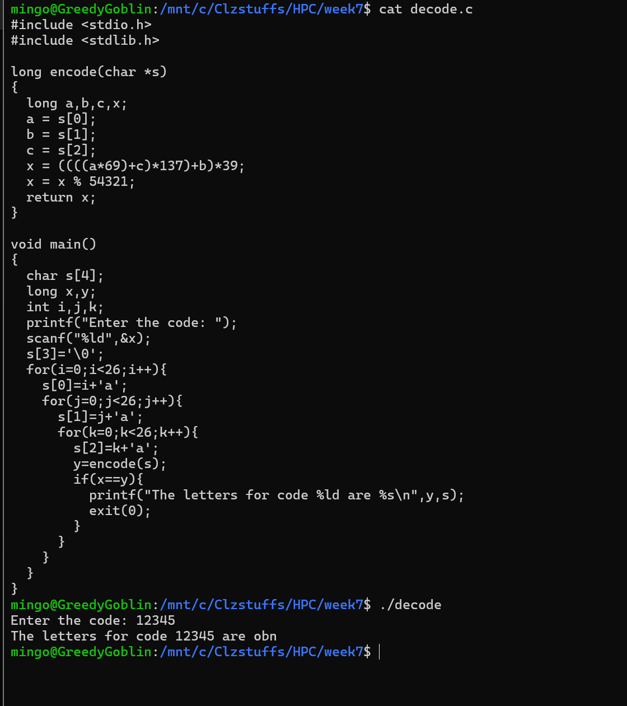
Modify the program to use the OpenMP for loop "collapse" method to spread the work across 16 threads.
